We can examine the following variables in order to analyse the given data: height, weight, age, grip strength, and fragility.Various analytics are

1. Descriptive Statistics:

Height: The average height is approximately 68.35 inches, with a range from 65.8 to 71.5 inches.

Weight: The average weight is approximately 133.8 pounds, with a range from 112 to 153 pounds.

Age: The average age is approximately 31.5 years, with a range from 17 to 51 years.

Grip Strength: The average grip strength is approximately 26.1, with a range from 19 to 31.

Frailty: There are 5 individuals labeled as "Y" for frailty and 5 individuals labeled as "N" for not frail.

1. Correlation Analysis:

To comprehend the links between variables, we can compute correlations between them. We could, for instance, look for any relationships between weight and fragility, age and grip strength, etc.

1. Frailty Analysis:

We can examine the variables connected to frailty. We can, for example, contrast the attributes (age, weight, grip strength) of people classified as "Y" for frailty with those classified as "N" for not frail.

1. Visualization:

To better grasp the distribution of the variables and any possible patterns or trends in the data, we can develop visualisations like box plots, scatter plots, and histograms.

1. Predictive Modeling:

We can create predictive models that forecast frailty based on other factors like age, weight, and grip strength, depending on the goal.

1. Statistical Testing:

We can run statistical tests to see whether there are any significant differences or correlations between variables if we have particular hypotheses to examine.

1. Line graph: show the relationship between age and grip strength. It is a line graph with age on the x-axis and grip strength on the y-axis. There is a line plotted on the graph that slants downwards from left to right, which shows a negative correlation between age and grip strength. This means that as age increases, grip strength tends to decrease.It is important to note that this is just a correlation, and it does not necessarily mean that there is a causal relationship between age and grip strength. There could be other factors that are affecting both age and grip strength, such as overall health, activity level, or genetics. Additionally, the graph does not show any error bars or confidence intervals, so it is difficult to say how much confidence we can have in the results.

Overall, the graph suggests that there is a negative correlation between age and grip strength, but more research would be needed to determine if there is a causal relationship between the two variables.

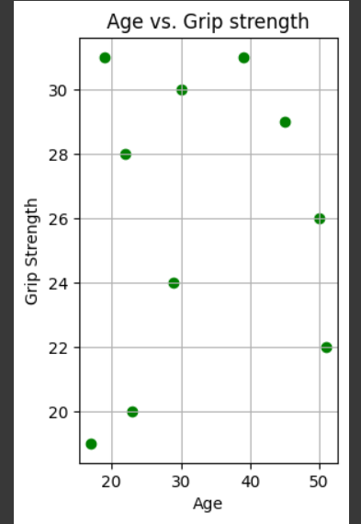

1. Heat map: It shows the relationships between six variables: height, weight, age, grip strength, frailty numeric, and an unnamed variable .The heatmap uses a color scale to represent the strength and direction of the correlation between each pair of variables. Red colors indicate a positive correlation, meaning that the two variables tend to increase or decrease together. Blue colors indicate a negative correlation, meaning that when one variable increases, the other variable tends to decrease. The intensity of the color represents the strength of the correlation, with darker colors indicating stronger correlations.

